Stylistic Elements of an Academic Paper
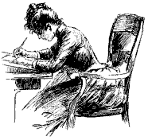
  - Begin with a clear thesis/hypothesis.
  - Avoid first and second person pronouns.
  - Don’t use contractions.
  - Avoid unnecessary questions, whether direct or rhetorical.
  - Avoid logical and emotional fallacies.
  - Pare sentences down to the minimum. Let every word count.
  - Strive for balance.
  - Reach qualified conclusions.
Source: Mark A. Spalding, 2010.

